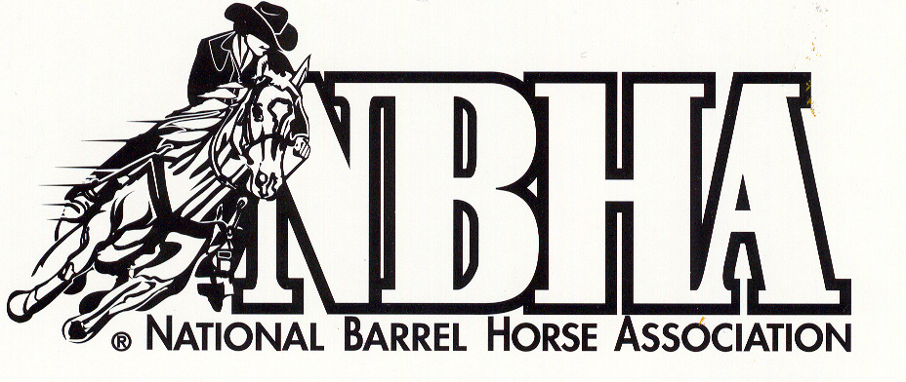
Oklahoma District 9
43158 CS 2550
Apache, OK 73006

We have a website address; www.nbhaok09.com. We will continue to make posts on Facebook, email, paper copies and will have newsletters available at each race for those who do not have access to a computer. Please take time to see who our sponsors are so that you can support them as often as possible.

