< < < BANNER SPONSORS > > >



< < < BANNER SPONSORS > > >


< < < BANNER SPONSORS > > >
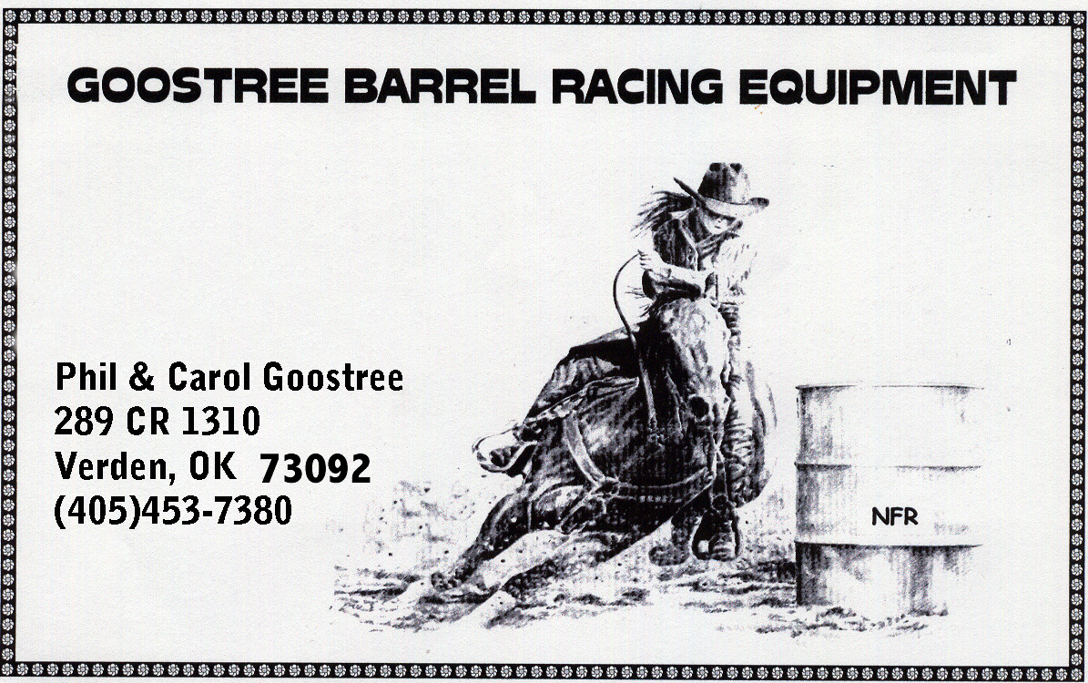



< < < BANNER SPONSORS > > >



BANNER SPONSORS



>>>>>BANNER SPONSORS<<<<<





PLEASE TAKE THE TIME TO CHECK OUT WHO OUR ADVERTISING SPONSORS ARE AND SUPPORT THEM AS OFTEN AS POSSIBLE!! WITHOUT THESE FINE BUSINESSES OUR END OF THE YEAR DISTRICT AWARDS WOULD BE LIMITED. THANK YOU

