LANA SCAMMAHORN ~ Director ~ nbhaok9@yahoo.com ~580-425-1069
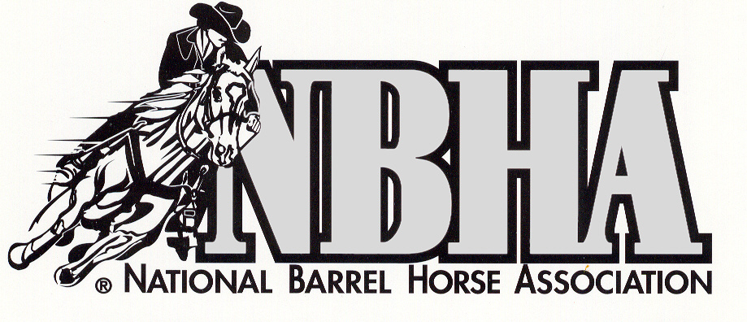

~2024 ADVERTISING~
Anadarko Vet Clinic ~ Anadarko ~ PM
Apache Co-Op~Apache, Ft. Cobb, Elgin, Chickasha-LS
B & B Farms-Hay for Sale~Elk City~BR
Beavers Animal Hospital, Inc. ~ Lawton ~ HW
Buzbee, Upchurch, Squires,&Eastwood
Attorneys-at- Law~Anadarko~KS
CAT Mechanical, Inc C.Thompson Heat/Air/Refrid/
CJ’s Southwest Tire, Inc. ~ Weatherford ~ LS
Country Claws and Paws~Apache~DM
Cowgirl Beef~TD
Dr. Jill’s Chiropractic Care~Fletcher~JH
Entz Auction~Hydro JE
First State Bank~RH
Full Pull Performance Diesel~Edmond~ZR
4B Oil Company~Anadarko~PC
Goober House~Carnegie~MH
Hackney’s 66~Anadarko~PM
Haugen Real Estate~BH
Hall & Estell Law Firm~OKC~~HD
Jen’s Equine Performance Therapy~JS
Michael Doyle CPA~Elgin~LS
M&M Arena ~ Binger ~ MH
Oakridge Equine~Edmond
Phil’s Cycle &ATV~El Reno~MM
Sage Rider~Stafford,TX~A&PM
Security State Bank-Cheyenne~LK
Skyys the Limit~skyysthelimitcc@gmail.com~KT
Spear’s Horse Boarding~LS
TCJ Oilfield Services~Elmer~SL
Trailertec-Trailer Repair, LLC~Elk City~SJ
Tropical Travels w/Margie Wilmarth~JT
Weichel Cattle, LLC~Cordell~AW

PLEASE TAKE THE TIME TO CHECK OUT OUR AD/SPONSORS AND SUPPORT THEM!!

2024 NBHA OK09 RACE SCHEDULE

Feb. 17*~M&M Indoor Arena~Binger~West of Binger

Sat. Race Ex. @12:00 Race @2:00

>>>>>>>>>>>>>>>>>>>>>>>>>>>>>>>>>>>>>>>>>>>>>>>>>>

March 2*~NBHA Super Show~Heart of Okla Expo~Shawnee

Sat. Race Enter online sgp.events

Point Race only for OK09

March 16*~Canadian Co. Expo Arena~El Reno
Sat. Race Enter online Tri K events
Point Race only for OK09
>>>>>>>>>>>>>>>>>>>>>>>>>>>>>>>>>>>>>>>>>>>>>>>>>>
Apr. 7~~Redland’s Com College Royse Ranch Arena~El Reno
Ex @ 3:00 Race @ 5:00
>>>>>>>>>>>>>>>>>>>>>>>>>>>>>>>>>>>>>>>>>>>>>>>>>>

Apr 12*~~Heart of Okla. Expo Center~Shawnee
Fri. Race @ 12:00 and 7:00 (enter w/NBHA state finals)
Point race only for OK09
>>>>>>>>>>>>>>>>>>>>>>>>>>>>>>>>>>>>>>>>>>>>>>>>>

April12-14~ Heart of Okla Expo Center-Shawnee
OKLA. NBHA STATE CHAMPIONSHIP
QUALIFIED MEMBERS
>>>>>>>>>>>>>>>>>>>>>>>>>>>>>>>>>>>>>>>>>>>>
May 19~~~Red River Cowboy Church Arena~Mangum
1001 N. Byars Ave
Ex. @2:00 Race @4:00
>>>>>>>>>>>>>>>>>>>>>>>>>>>>>>>>>>>>>>>>>>>>>>>>>>
May 25*~~~~~~WR Arena~Elk City
Sat. Race* 10372 N 2030 Rd 73644 Time TBA
Point Race only for OK09
>>>>>>>>>>>>>>>>>>>>>>>>>>>>>>>>>>>>>>>>>>>>>>>>>>

June 2~ Red Stevens Park Arena-Gracemont

Ex. @ 5:00 Race @ 7:00

>>>>>>>>>>>>>>>>>>>>>>>>>>>>>>>>>>>>>>>>>>>>>>>>>>
July 7~~~Red Stevens Arena~Gracemont
Ex. @ 5:00 Race @ 7:00
>>>>>>>>>>>>>>>>>>>>>>>>>>>>>>>>>>>>>>>>>>>>>>>>>>
July 21-27~NBHA YOUTH &TEEN CHAMPIONSHIPS
PERRY, GA QUALIFIED MEMBERS
>>>>>>>>>>>>>>>>>>>>>>>>>>>>>>>>>>>>>>>>>>>>>>>>>>
August 4~~Nance Fair Park Arena~Clinton
Ex. @5:00 Race @ 7:00
>>>>>>>>>>>>>>>>>>>>>>>>>>>>>>>>>>>>>>>>>>>>>>>>>>
Sept. 8~~~Nance Fair Park Arena~Clinton
Ex. @5:00 Race @ 7:00
>>>>>>>>>>>>>>>>>>>>>>>>>>>>>>>>>>>>>>>>>>>>>>>>>>
Sept. 22~~MM Out Arena~Binger
Ex. @4:00 Race@6:00
>>>>>>>>>>>>>>>>>>>>>>>>>>>>>>>>>>>>>>>>>>>>>>>>>>
Oct. 6~~~Redlands CC Arena~El Reno
Ex. @ 3:00 Race @5:00
>>>>>>>>>>>>>>>>>>>>>>>>>>>>>>>>>>>>>>>>>>>>>>>>>>
Oct. 13~~~Redlands CC Arena~El Reno
Ex.@3:00 Race @5:00
>>>>>>>>>>>>>>>>>>>>>>>>>>>>>>>>>>>>>>>>>>>>>>>>>>
Oct. 27-Nov. 2~NBHA OPEN & SENIOR CHAMPIONSHIPS
PERRY, GA. QUALIFIED MEMBERS
>>>>>>>>>>>>>>>>>>>>>>>>>>>>>>>>>>>>>>>>>>>>>>>>>>
Nov 16*~~~~MM Indoor Arena~Binger
*Sat. Race Ex .@12:00 Race @ 2:00
Award presentation 30 min. after race conclusion
>>>>>>>>>>>>>>>>>>>>>>>>>>>>>>>>>>>>>>>>>>>>>>>>>>
~~~~CASH ONLY AT RACES~~~~

This allows us to have the cash to make payouts.
NEGATIVE COGGINS REQUIRED

