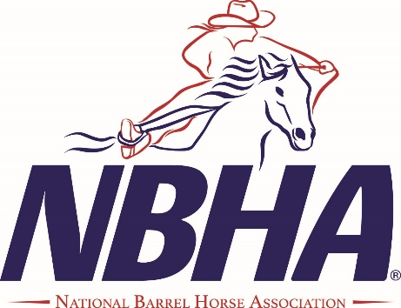
OK09

The 2024 NBHA OK09 race season is upon us. We would like to ask you to consider
letting us share your business information with our current 100+ members and
prospective new members through our Ad/Sponsor Program.

NBHA District 09 covers 11 counties in the district. The counties are: Beckham, Blaine, Caddo, Canadian, Custer, Grady, Greer, Harmon, Kiowa, Roger Mills, and Washita. There were 14 scheduled barrel events in the district last year and 15 are on the calendar for 2024! Riders from around the state regularly attended our races. They saw our ad banners, newsletters, logo t-shirts and many more utilized our website and Facebook page. It was estimated that at least 300+ barrel racers, with their families and friends, attended our scheduled races held in Binger, Clinton, Shawnee, El Reno and Gracemont, and Mangum and Elk City arenas are added this year!

NBHA OK09 racers compete for cash prizes, local district awards, and point accumulations to qualify them for state and national levels of competition in open, senior and youth divisions. ALL YOUTH AND TEENS RECEIVE SPECIAL AWARDS OF SOME TYPE.

Ad/Sponsorships range in price according to the amount of publicity you will receive from them. The Banner ad, which is hung at EVERY sanctioned race, including our yearly State Finals, is highly recommended. Ad banners are hung in well viewed areas to receive exposure to members, as well as spectators, at the events. Oklahoma is the proud sponsor of an NBHA SUPER SHOW this year that will bring in racers from nearby states as well! The State level competition, which will be held in Shawnee April 12-14, will host close to 300+ barrel racers, their families, and friends!

All businesses in our Ad/Sponsorship program will be listed on our website and highlighted on our Facebook page. We offer a link (if available) to your website from ours with select ads. Our members will be able to connect quickly with your web page and become familiar with your business objective.

Thank you for your interest.

Respectfully,

Lana Scammahorn District OK09 Director

Pam Martin District OK09 Representative

